

Mathematics Specialist Unit 2

Test 4

Trigonometric Identities and Matrices

Name: ______________________ Total Marks:__________

Task type: Response

Time allowed for this task: 60 minutes, in-class, under test conditions
Section One: Calculator-free 38 minutes ( 34 marks)
(3 Minutes Reading – 35 Minutes Working)
Section Two: Calculator-assumed 22 minutes ( 20 marks)
(2 minutes Reading - 20 minutes working)

Materials required: Calculator with CAS capability (to be provided by the student)

Standard items: Pens (blue/black preferred), pencils (including coloured), sharpener, correction fluid/tape, eraser, ruler, highlighters

Special items: Drawing instruments, templates, notes on one unfolded sheet of
A4 paper, and up to three calculators approved for use in the WACE examinations
Formula sheet

Marks available: 54 marks

Task weighting: 7%

Section One : Calculator Free 34 Marks
Time Allowed 30 minutes

Question 1 (8 marks)

For the following matrices
$A=\left[\begin{matrix}3 & 1 \\ 7 & 2\end{matrix}\right]$ $B=\left[\begin{matrix}1 & 6 \\ 3 & -4\end{matrix}\right]$ $C=\left[\begin{matrix}4 \\ 1\end{matrix}\right]$

- Determine the following, if not possible explain why. (5 marks)
- $B-A$

- $C+B$

- CB

- BC

- $A^{-1}$

- Use a matrix method to solve the system of equations $3x+y=-5$ and $7x+2y=-14$.
(3 marks)

(iv) BC
Question 2 (9 marks)

Let $A=\left(\begin{matrix}-1 & 1 \\ -3 & 0\end{matrix}\right), B=\left(\begin{matrix}b+3 & 5 \\ 2 & b\end{matrix}\right), C=\left(\begin{matrix}-3 \\ 5\end{matrix}\right)$ and $D=\left(\begin{matrix}2 \\ 1\end{matrix}\right)$, where $b$ is a constant.

(a) Simplify $AC+3D$. (3 marks)

(b) Determine the value(s) of $b$ if $B$ is singular. (3 marks)

(c) Use a matrix method to determine $X$ if $2X+AX=5D$. (3 marks)

Question 3 (7 marks)

- Write down the equation of the following graph?
(4 marks)

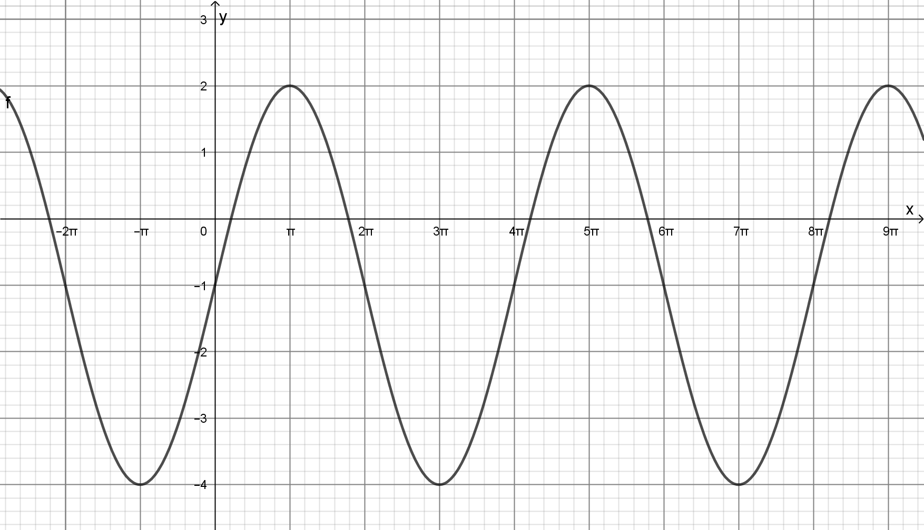

- Sketch the graph of $y=2\sec{(x-\frac{π}{2})}$ on the grid below.
(3 marks)
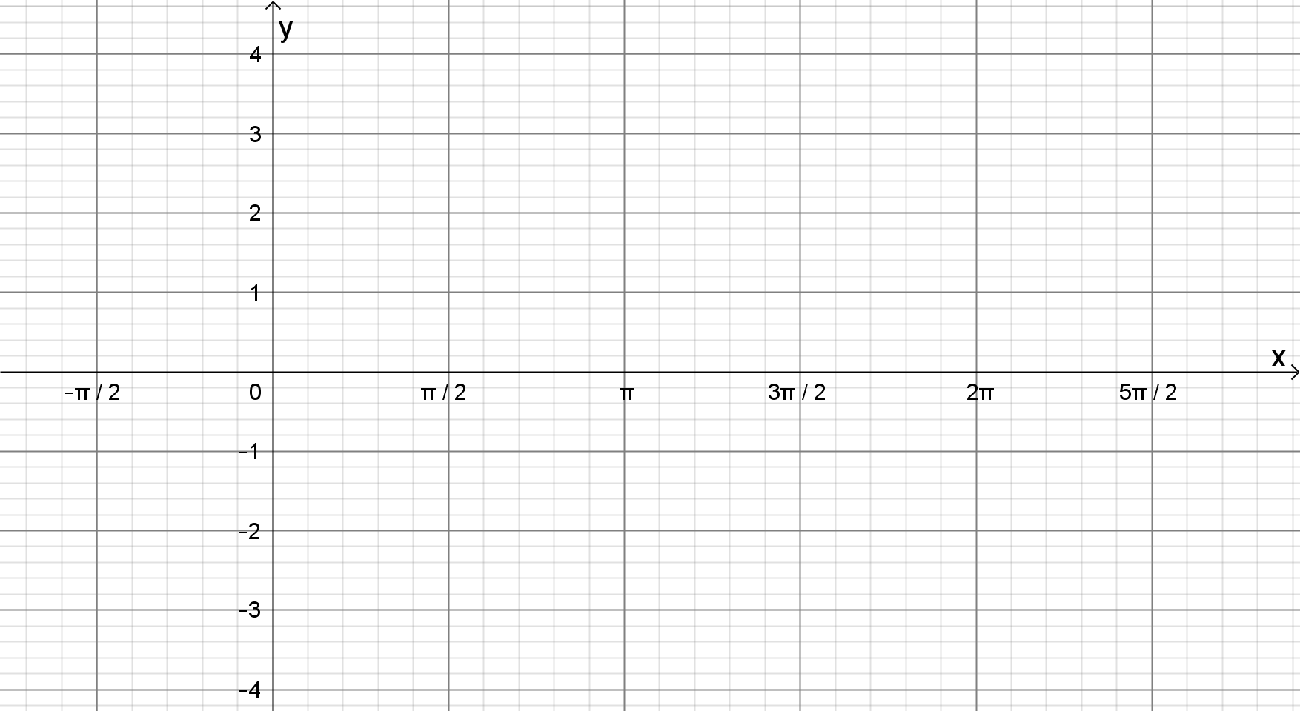

Question 4 (10 marks)

- Solve $2\cos{(x+\frac{π}{2})}=1$, for $0≤x≤2π$
(3 marks)

- Solve $2\sin^{2}{x}+\sin{x}-1=0$ for $0≤x≤360°$
(4 marks)

- Find all the solutions for the equation $\sin{x}=\sqrt{3}\cos{x}$
(3 marks)

Section Two : Calculator Assumed 20 Marks
Time Allowed 30 minutes Name:_______________________

Question 5
(6 marks)
A system of equations is given by
$$2x+ay=-10 \\ 4y-x=11$$

(a) Let the constant $a=-5$.

(i) Express the system in matrix form $AX=B$, where $X$ and $B$ are column matrices.
(2 marks)

(ii) Determine $A^{-1}$ and demonstrate use of matrix algebra to solve the system for $X$.
(3 marks)

(b) Determine the value of $a$ for which the system has no solution. (1 marks)

Question 6
(7 marks)

The air pressure in a tank can be modelled by the equation

$p=a+b\cos\left(c\left(t+d\right)\right)$ for $0≤t≤24$

where $p$ is the pressure in kPa, $t$ is the time in hours after midnight and all other variables are positive constants.

The air pressure first reached a minimum of $92$ kPa when $t=0.5$ h and then rose during the next $3$ hours to a maximum of $116$ kPa before decreasing again.

(a) Determine the value of each of the positive constants $a, b, c$ and $d$. (4 marks)

(b) Use the model to determine

(i) the air pressure at $6$ pm. (1 mark)

(ii) the time of day, to the nearest minute, that the pressure first reached $111$ kPa.
(2 marks)

Question 7
[7 marks]
The Perth Pergola Company manufactures pergolas, sheds and garages. Each item requires a number of nuts, bolts and washers:
Pergolas need 35 nuts, 20 bolts and 10 washers.
Sheds need 70 nuts, 30 bolts and 20 washers.
Garages need 56 nuts, 34 bolts and 18 washers
a) Represent this information in matrix form (2 marks)

The Perth Pergola Company has a manufacturing goal of 20 pergolas, 40 sheds and 35 garages.
b) Use matrix methods to show how many nuts, bolts and washers are needed. (3 marks)

The cost of each nut, bolt and washer is 15c, 25c and 5c , respectively.
c) Use matrix methods to find the how much the of nuts, bolts and washers would cost for the company to reach their goal. (2 marks)

